1. Proposed Position | : | Senior Software Engineer |  |  | 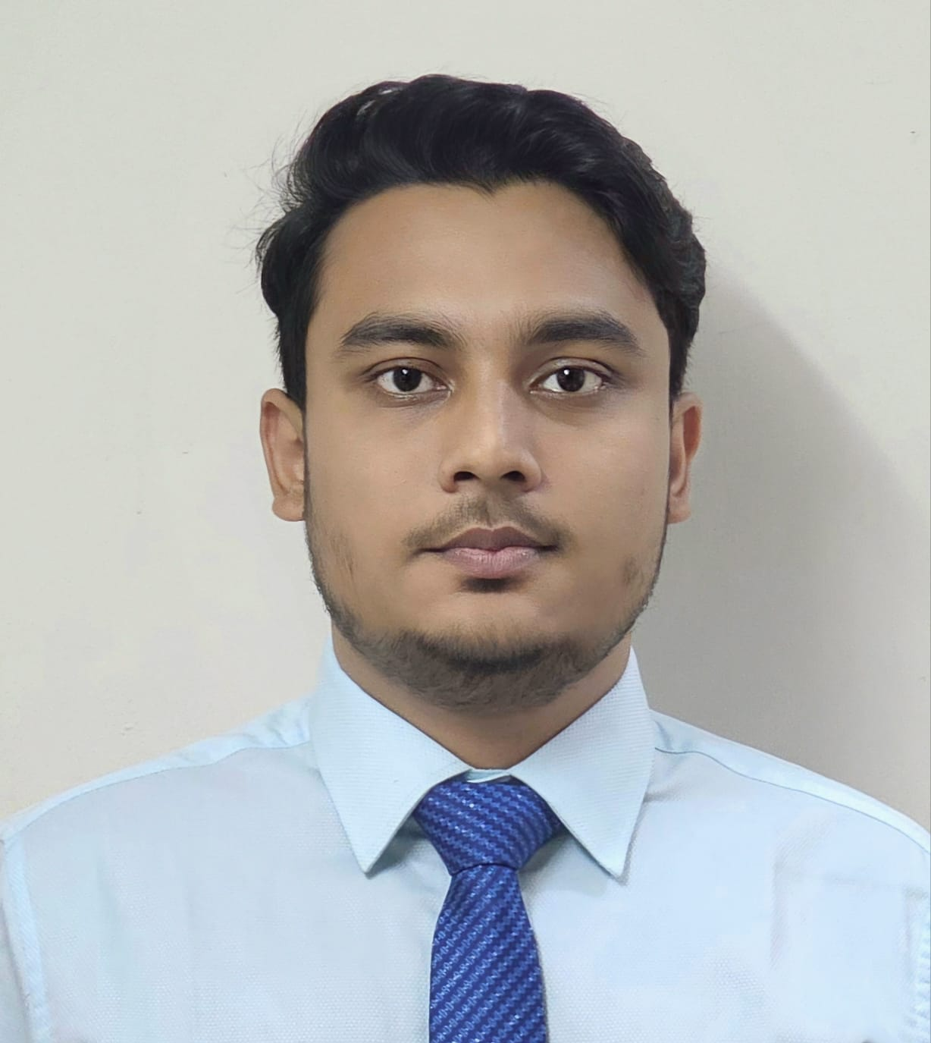
2. Name of Staff | : | Mahathir Mohammad Bishal
3. Date of Birth | : | November 12, 1998
4. Nationality | : | Bangladeshi
5. Membership in Professional Society | : | - The Institution of Engineers, Bangladesh
6. Education | : | - B.Sc. Engineering (Computer Science Engineering) from Chittagong University of Engineering & Technology , 2022  - H.S.C. from Dinajpur Board in 2016  - S.S.C. from DinajpurBoard in 2014
7. Other Training | :
  SL | Training/Certification Title
  1 | Master Spring Boot 3 & Spring Framework 6 with Java 2024
  2 | Docker for the Absolute Beginner - Hands On - DevOps
  3 | C# .NET Core 8 with MS SQL Complete Beginner to Master 2023
  4 | The Complete JavaScript Course 2022: From Zero to Expert!
  5 | The Complete Git Guide: Understand and master Git and GitHub
  6 | Machine Learning A-Z™: Hands-On Python & R in Data Science
  7 | Neural Networks and Deep Learning for Natural Language Processing
8. Languages & Degree of Proficiency | : | Language Speaking Reading Writing  English Excellent Excellent Excellent  Bangla (mother tongue) Excellent Excellent Excellent
9. Countries of Work Experience | : | Bangladesh – 04 years
10. Employment Records & Experience:
Employer |  |  | : | From |  | To
1. Telcobright Ltd.  Senior Software Engineer |  |  | : | May 2020 |  | Till Date
Experience:
- Lead software development projects, ensuring alignment with business goals and client expectations.
- Collaborate with stakeholders to gather and document requirements, translating them into technical specifications.
- Mentor junior developers, providing guidance and support to enhance their skills and productivity.
- Coordinate with project managers to ensure project plans align with business objectives and timelines.
- Conduct code reviews, ensuring adherence to best practices and coding standards.
- Troubleshoot and resolve complex technical issues, providing innovative solutions.
- Ensure all deliverables are feasible, prioritized, and traceable throughout the project lifecycle.
- Maintain up-to-date knowledge of industry trends and technologies, applying them to improve existing systems.
- Foster a collaborative team environment, promoting knowledge sharing and continuous improvement.

11. Subject Matter Specializations
- Languages: Java, C#, C/C++, Python, JavaScript
- Frameworks: Spring, ASP.NET, Django
- Tools: Git, Jenkins, JIRA, Confluence, MS Excel
- Experienced in all SDLC phases
- Knowledge of Agile and Waterfall methodologies
- Skilled in SQL and NoSQL databases
- Database design and performance tuning
- Strong problem-solving abilities
- Skilled in performance analysis and optimization
- Proficient in AWS, Azure, Google Cloud
- Expertise in Terraform, Docker, Kubernetes

Certification:
I, the undersigned, certify that (i) I was not a former employee of the client immediately before the submission of this proposal, and, (ii) I have not offered my CV to be proposed by a Firm other than this Consultant for this assignment, and (iii) to the best of my knowledge and belief, this bio data correctly describes myself, my qualifications, and my experience. I understand that any willful misstatement described herein may lead to my disqualification or dismissal, if engaged.

I have been employed by Telcobright Limited. as a senior software engineer. Indicate “Yes” or “No” in the boxes below:

YES | ✔ | NO
Signature |  |  | 
Date of Signing |  |  | 05 / 06 / 2024  (Day / Month / Year)

